
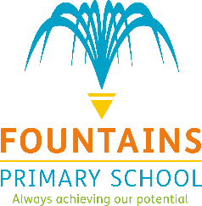
Online Safety Meeting Minutes
Summer 1 2026
Staff Present – Miss Knight, Miss Palmer and Mrs Price
Present – Phoenix (Dolphins), Oliver (Starfish), Archie and Edward (Rays) Alfie (Lobsters) Pharrel
Apologies – Imogen (Seahorses), Logan (Turtles), Enzo (Jellyfish). Abdul-Haadi (Penguins) CJ (Seals), Jack (Whales) Spencer (Fish) Brody (Starfish) Freddie (Jellyfish) Jacob (Turtles)
Agenda –
- 360 degree award review
- Staff training on INSET Day
- New reporting button on the school website
- Online safety posters for classrooms
Minutes –
The Online Safety Committee met on Friday 8 May 2026. They discussed the school’s Online Safety 360 review and looked through the national online safety posters, focusing on the use of AI and recognising real and fake images online.
The committee also recapped what to do if they ever feel unsafe online and discussed the importance of identifying ‘safe adults’. Children were able to recall that Mrs Kobylanski is the school’s Designated Safeguarding Lead.
Members then thought about the rules that all children need to know to stay safe online and worked together to create online safety posters. The committee showed a good understanding of how to keep themselves safe and who to talk to if they are worried or unsure about anything online.
Any other business –
- None
Actions–
- Go on the Bletchley Park trip
- Share online safety videos to all classes to watch with their children
- To distribute online safety posters to all classes

Next Meeting – Friday 3rd July 2026

